EXPERIMENT-6
DCL Commands – GRANT, REVOKE

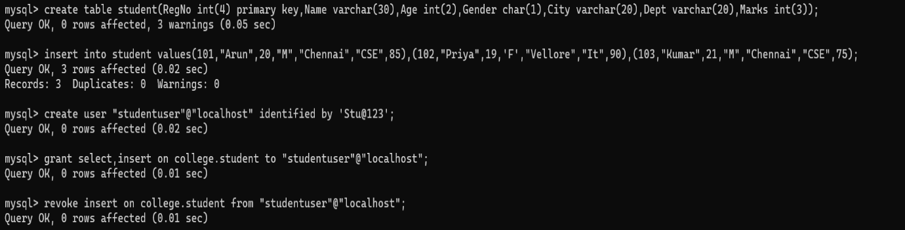

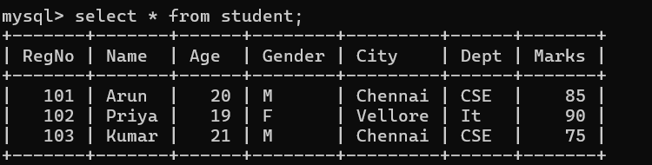

EXPERIMENT-7
SELECT with various clauses – WHERE, pattern matching

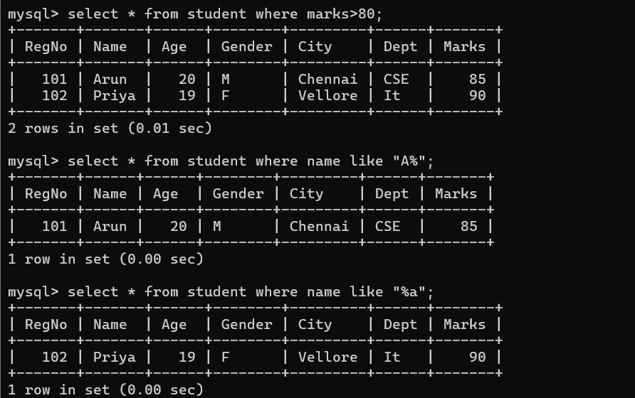
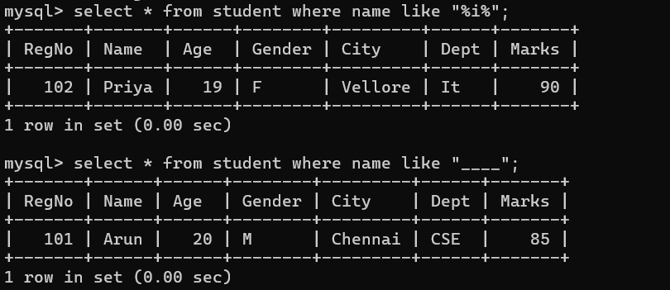

EXPERIMENT-8
SELECT with various clauses – BETWEEN, IN, Aggregate Function
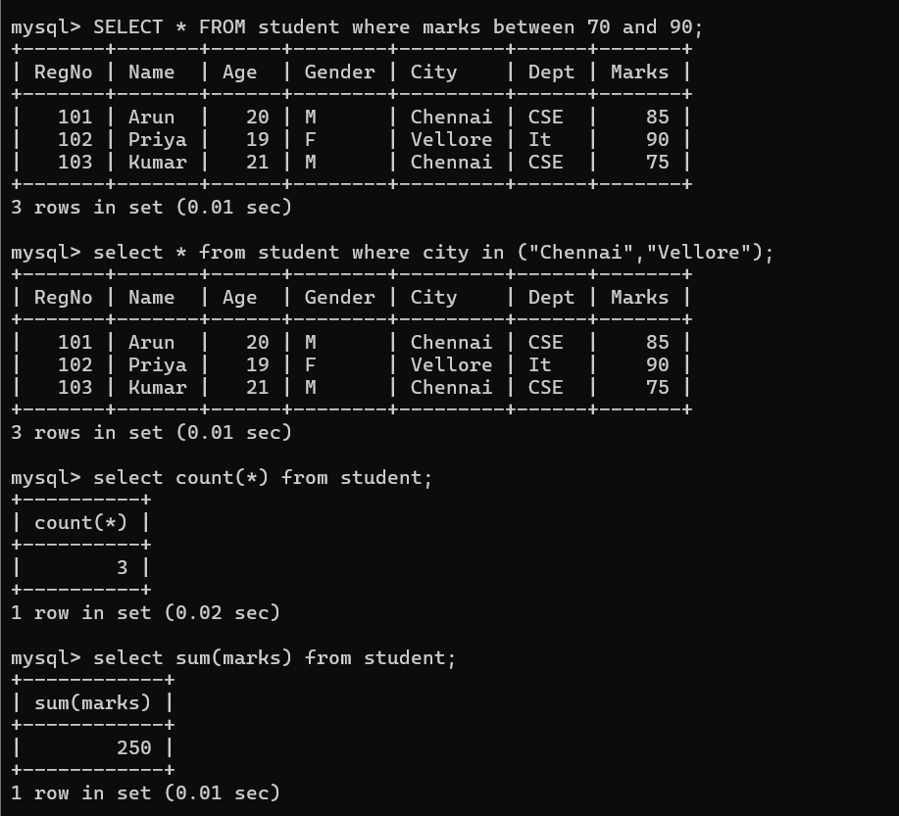

EXPERIMENT-9
SELECT with various clauses – GROUP BY, HAVING, ORDER BY
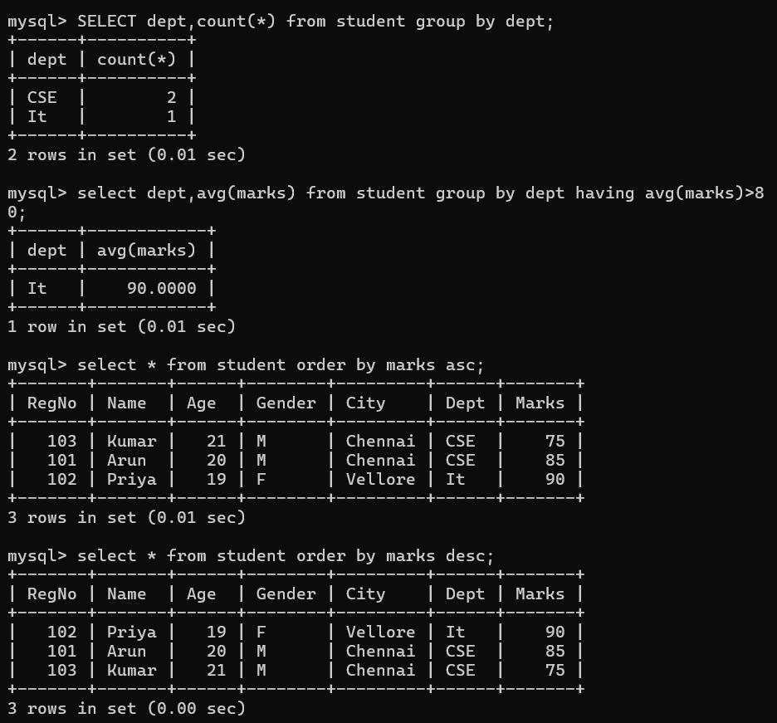

EXPERIMENT-10
Query with SubQuery& Correlated Query
